***Florida International University***

***School of Computing and Information Sciences***

Software Engineering Focus

Feature Document

User Story #887

**Team Member:**

Pedro Carrillo

**Product Owner(s)​**:

Gummi Traustason

**Mentor(s)​**:

Masoud Sadjadi

**USER STORY​** - **“Start a game in Beat Timer mode”**

* As a user I would like to start a game using the beat timer game mode which will allow me to test my reactions during a customizable window of seconds

Acceptance Criteria

* Seconds should be customizable (S)
* The pads change color each S seconds
* I can see my score at the end of the game

**Use Case Diagram**

Use case for start a game in Beat Timer mode

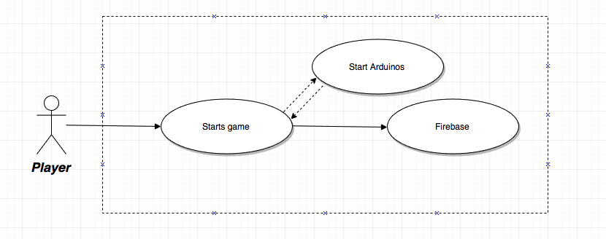

**Sequence Diagram**



**Class Diagram**

Untitled Diagram.png

**Unit and Integration Testing**

Test Case 1

○ **Purpose:** Test the beat timer mode

○ **Precondition:** User is already logged in and there is arduinos connected

○ **Expected Result:** Player can play a game by touching the pressure sensors and the pads will change color each ‘S’ Seconds

○ **Actual Result:** Couldn’t test because problem with hardware

○ **Status: PASSED**

Test Case 2

○ **Purpose:** Can’t set the frequency without setting time first.

○ **Precondition:** User is already logged in and there is arduinos connected

○ **Expected Result:** User should get a message that they can’t select the frequency time without selecting time first

○ **Actual Result:** User can see a message that tells him what to do first

○ **Status: PASSED**

**Visual Diagram**

